THARAKA UNIVERSITY COLLAGE

DEPARTMENT OF SCIENCE AND ENGINEERING

COSC 0281

SOFTWARE PROJECT 1

NAME:

MICHAEL MWAURA NGARUIYA

TOPIC:

**DECLARATION**

I declare that this is my original work and has not been presented to any other institution for academic grading the resources have been duly acknowledged

NAME **…………………………………………………………………………………….**

SIGNATURE **………………………………………………………………………………**

DATE **………………………………………………………………………………………**

I confirm that the work in this research proposal was carried out by the student under my supervision and has been submitted for examination with my approval

NAME **…………………………………………………………………………………….**

SIGNATURE **………………………………………………………………………………**

DATE **………………………………………………………………………………………**

**DEDICATION**

**ABSTRACT**

**ACKNOWLEDGMENT**

I take this chance to thank might God for seeing through the process of the study. I would also like to acknowledge the tireless effort of my supervisor Mr. kevin Tuei from the start of documentation of the proposal to the end. A special thanks to my parents for their support their support and encouragement

**ABBREVIATIONS AND ACRONYMS**

Table of Contents

DECLARATION**…………………………………………………………………………**

DEDICATION**…………………………………………………………………………….**

ACKNOWLEDGEMENT**……………………………………….......................................**

ABSTRACT**………………………………………………………………………………**

ABBREVIATIONS AND ACRONYMS**…………………………………………………**

CHAPTER ONE: INTRODUCTION 9

1.0 Background of the Study 9

1.1 Statement of the problem 10

1.2 The Purpose of the Study 11

1.3 Research Objectives 12

1.4 Research Questions 13

1.5 The Scope 14

1.5.1 Limitation 14

1.5.2 Delimitation 14

1.6 Significance of the Study 15

1.7 Definitions of Terms 16

CHAPTER TWO: LITERATURE REVIEW 17

1.8 Introduction 17

1.9 Need of Motivation for Learning theories 17

1.10 Research Study on Gamification for Learning 17

1.11 Summary of the Literature Review 18

CHAPTER THREE: METHODOLOGY 19

1.12 Introduction 19

1.13 Research design 19

1.13.1 Quantitative study 19

1.13.2 Qualitative study 19

**1.14 PROJECT TIMELINE** 20

**1.15 BUDGET** 21

Bibliography 27

**List of Figures**

Figure 1: Gamification System Flowchart 23

Figure 2:Gamification User Case Diagram 24

Figure 3: Corresponding Dashboard 25

Figure 4: Corresponding Leaderboard Area 26

Figure 5:User Profile Dashboard Gamified 27

# CHAPTER ONE: INTRODUCTION

## Background of the Study

For more decays of years, education researchers have been emphasizing on important of engaging students in the learning environment to flavor their participation in class in order to improve their performance. As research indicates student’s performance has been merely poor at broad spectrum in various subjects in school. A need of reducing failing of grades for students creates a need to investigate techniques that can be used to increase student’s participation in the classroom. This drives me to look forward to investigate possible techniques that can help to improve their performance in class. Gamification being one of the popular techniques to enhance student participation in the classroom, the term been referred to as “a process of adding game mechanics in non-game context or environment to increase collaboration, participation, interactions, etc.”. This will enable students to be involved in competitions with their fellow students, in that completion of task would lead to awarding of points, reward(s), badges, etc. This will also enable learners to see the progression on their achieves in the leaderboard such as group high status or even person contribution within the game. This will increase student’s engagement with the content allowing them to spend more time on the content currently working on, with less time on understanding the concepts.

## Statement of the problem

For the past decades, learning experience in education didn’t mainly focus on learner’s competency but rather it highly focused on knowledge-based, hence discouraging learners in assessing the content that seem not enjoyable, to most of them and as well as discouraging assessment of learner’s potential hidden skills or competence, abilities, etc. Therefore, learning outcomes were gradually recorded to be poor, whereby learners felt demotivated or discouraged in their learning process. This could have been the cause of increase in drop out and wastage rates in education sectors as well as high unemployment and lack of jobs after schooling, most probably due to lack of required and proper skills that job demands.

Therefore, there is a need for coming up with a platform that gamifies academics affairs for the learners in order to make the learning process enjoyable, fun, interactive, collaborative, competitive and intrinsically motivating them to proceed to the next level(s). This research is meant to set such a platform that may assist in applying gamification principles in the learning environment to engage and motivate learners in accomplishment of their task into their learning activities will greatly improve their performance.

As Wikipedia defines gamification as application of game design elements and game principles in non-game context. Research has also indicated that gamification increases users/learner’s activity of applications that helps improve retention of competence. Also, gamification has increasingly attacked the interest of educators due to its potential to foster motivation and behavior change in the learning context. Game elements seem to be a more promising method to enhance learning experience in or out of the class as they include use of rewards, avatars, points, badges, levels, scores leaderboards, progress bars, etc. in order to assess learning progress and achievements. Competence gamifying tracking system will help in tracking learners’ achievements that will either show their progression or regression and providing features that motivate and engage them.

## The Purpose of the Study

The purpose of the study is to find out various techniques that can help improve student’s engagements in the learning processes and improve their performance.

## Research Objectives

1. To find out what favor student engagements, participations, collaborations, interactions in the classroom
2. To find out ways to improve learning outcomes for learners by use gamification techniques to motivate, and engage them into learning activities
3. To find out ways to rate the progress for learners’ achievements, engagements in the learning activities during learning process
4. To establish motivating factors and techniques that motivate learners to accomplish their task very effectively
5. To find out ways optimize learning, enhance learners’ abilities, gave learning a purpose, support change of behavior into the learning environment

## Research Questions

1.   To determine whether gamification techniques help in improving learning outcomes, intrinsically motivate and engage learners in their learning experience

2.  what are the impacts of gamification principles, game elements, and game mechanism, on education in improving participations collaborations, interactions for learners

3. What are the perceptions of the students who participate in a gamified environment

4. To determine whether gamification can create environment where student will outperform their peers in non-game class

## The Scope

### Limitation

### Delimitation

## Significance of the Study

The findings of the study will help improve learner’s engagement, participations, collaborations, interactions and flavor motivation in the classroom that will results in improvements in their performance. It will also increase the appeal of learning processes, innovation of new ideas, fun, productivity and ability to retain knowledge.

## Definitions of Terms

# CHAPTER TWO: LITERATURE REVIEW

## Introduction

During last couples of years, a research on establishing techniques that can possibly improve learning experiences (***Juho Hamari, School of Information Sciences***) for learners has been a trending topic and gamification being one of the effective techniques to foster motivation, engagements, participations, interactions, and collaborations. As Weiner (**1992**), defines” Motivation as the study of the determinants of thoughts and actions”.

## Need of Motivation for Learning theories

According to study of Self-efficacy theory introduced by Bundura (1977) defines of Self-efficacy theory as “individual “confidence in their ability to organize and execute a given course of action to solve a problem or accomplish a task (cited in Graham and winner, 1996). Self-determination theory also outline that motivation is based on learners’ perceptions being in control of his or her own destiny. Whereas, self-regulation regarded being a variable attribute for learners, it been a process outlined by Zimmerman (1998) to help them learn in engaging in their lengthy research project. Also, Mok et all (2006) state that it also helps them to prepare for lifelong (mastery) learning that involve preparing them to make complex judgments about their work for future circumstances.

Then study of Goal of orientation theory (***D.A. Cook and A.R. Artino***) suggests that learners tend to engage in tasks that concerns with mastery of content, about doing better than others and self-determination theory proposed that optimal performance results from action motivated by intrinsic interest. This self-motivation (**SDT**) theory resulted development of intrinsic motivation and extrinsic motivation where intrinsic motivation: it’s inherits to a person; it is done for its own sake of a person interest without being pushed unlike to extrinsic motivation which it’s a outside the person (*Carina Soledad González González on 21 June 2015*).

However, according to achievement motivation theory which initially uttered by Atkinson in 1957, this theory is based on importance of individuals experience and their struggles to achieve a good performance. Atkinson also outlined that “engagement in achievement-orientation behaviors is the function not only of the motivation for success but also probability of success (expectancy) and the incentive value of success” (Oxford and Shearin,1994).

## Research Study on Gamification for Learning

Gamification appears to be an emerging trend in many sectors, including businesses, organization management, in-service training, health, social policy and education. Gamification defined as “use of game mechanics in non-game context” (Deterding, Dixon, Khaled, &Nacke,2011). Furthermore, being a “phenomenon for creating gameful experience” (Koivisto & Hamari, 2014). Gamification tries to meet satisfactory human desires or needs both real and virtual world such recognition, rewards, achievements, competitions, cooperation’s, etc. It uses distinct entities that combined with aesthetics of the game, that enables the creation of the experience of prayer.

According to kelvin Werbach (2012) the three elements of a gamified system are dynamics, mechanics and components whereby, mechanics are the processes that makes cause the development of the game that is behavior mechanics (focusing of human behavior and human psychology) and progression mechanics (a grouping of significant skills). Game elements includes; avatars, badges, points, collections, ranking, levels, virtual goods leader board achievements. etc. Remember those are not game, a game is built by a set of components that interact in order to get a comic or fun for the prayers. This has showed that applying principle of gamification in educational activities such as repeating the experimentation, thrust feedback cycles, adaption of the task to the skills levels, progressive intensification of the difficulties or facing challenges. This will help students improve their competency.

## Summary of the Literature Review

According to (***Jonna Koivisto***) the current research topic, they are indication that use of this game-based technique will incredibly increase user engagement in various activities, social interactions, quality and productivity of actions. More so, use of game element could help in teaching learners like how to code which reflected rapid search hits as subject for academic inquiry. Garter (**2014**) estimates that over 50% of different organization that manage their services through innovation processes will gamify their aspects in their businesses by the year **2015**.

# CHAPTER THREE: METHODOLOGY

## Introduction

This chapter consist of research site, research design, and type.

## Research design

### Quantitative study

A quantitative study is need to investigate a question about outperforming student from non-gamified environment. The epistemology for this design of the study includes objectivism and theoretical perspective (**set of assumption about reality**).

objectivism which deals with observing different groups and their relationship or association among them (peikoff,1967). This is mainly where the study will focus to determine how different sections of same course operate, this will include two main section one will be set up for gamified section and another will be used to control. For instance, during given semester a comparison will be made of different number of artifacts created by each class attendances, therefore, this data will be collected and will be showed in terms of percentages. Provided data from mid-term, final grades for each individual will help to determine the success of gamification and class average could of use to support gamification in the classroom.

### Qualitative study

Qualitative research was used for this study the import of gamifications for learning in the classroom.

#### Theoretical perspective

To clearly answer a question what student think about of participations in a course been taught with gamification, epistemology constructionism is need to be of use in the study. Crotty define constructionism as the construction of knowledge that is constructed out of interaction between people(crotty,1998). Students will have capabilities to construct knowledge though social interactions in persons and online discussion board.

## **PROJECT TIMELINE**

## **BUDGET**

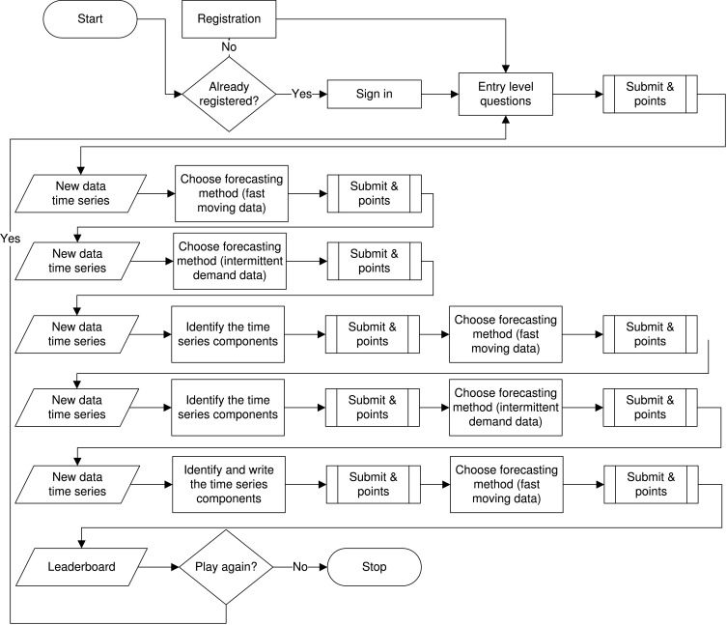

Figure 1: Gamification System Flowchart

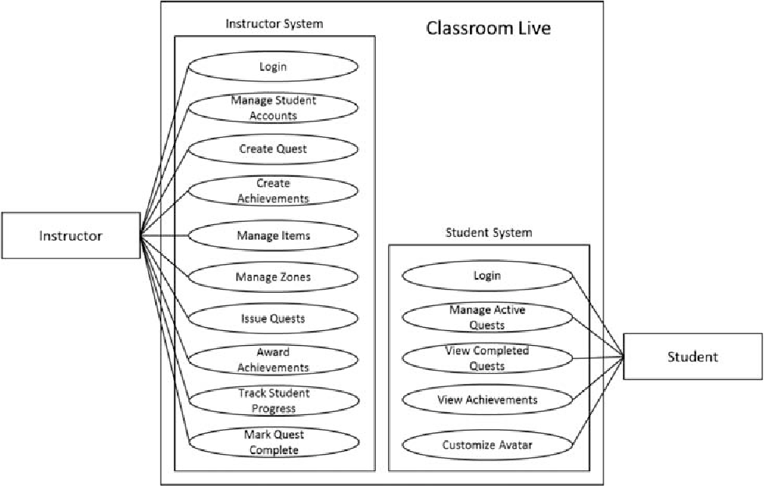

Figure 2:Gamification User Case Diagram



Figure 3: Corresponding Dashboard



Figure 4: Corresponding Leaderboard Area

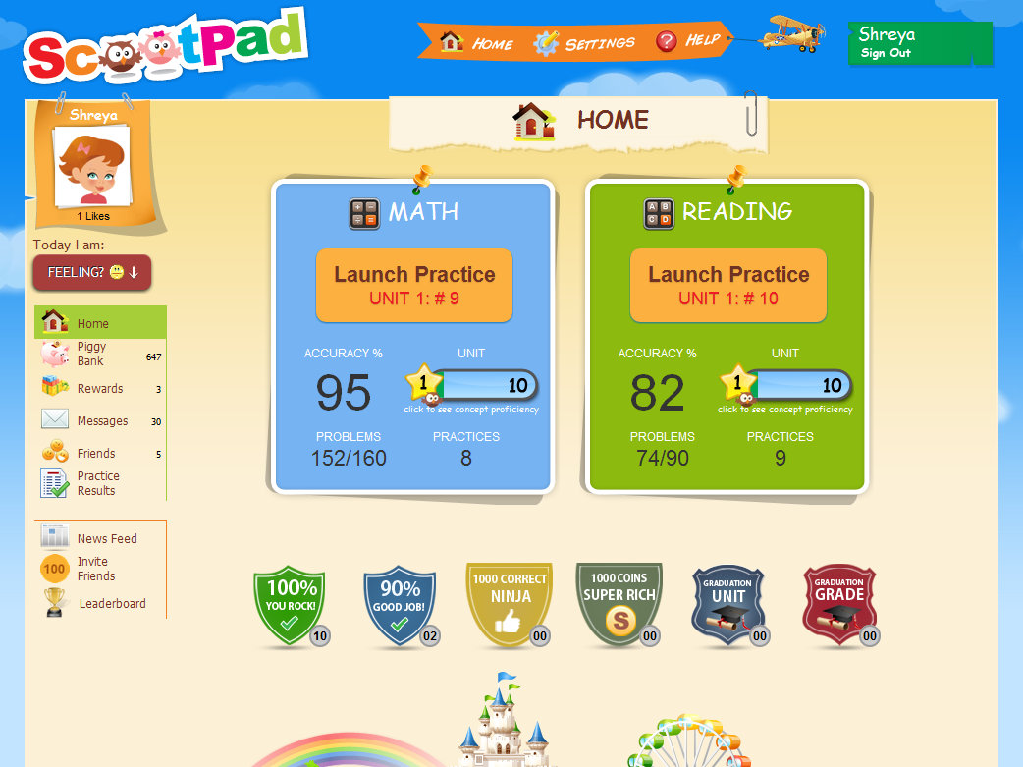

Figure 5:User Profile Dashboard Gamified

(Motivation theory in educational practice: Knowledge claims, challenges, and future directions., 2011; Methodological proposal for gamification in the computer engineering teaching, 2014; Motivation Theories and Implications for Teaching and Learning in the Biosciences, 2009)

# Bibliography

1. Cohen, S. (2016). *INVESTIGATING THE IMPACT OF GAMIFICATION ON STUDENT PERFORMANCE IN A SECONDARY SCIENCE CLASSROOM.*
2. Earp, J., Ott, M., & Caponetto, I. (2014). *Gamification and Education: a Literature Review.* Retrieved from https://www.researchgate.net/publication/266515512
3. Jurgelaitis, M., Čeponienė, L., & Drungilas, V. (n.d.). *Using Gamification for Teaching UML in Information System Design Course.*
4. Öztürk, E. (n.d.). *CONTEMPORARY MOTIVATION THEORIES IN EDUCATIONAL PSYCHOLOGY AND LANGUAGE LEARNING: AN OVERVIEW.*
5. Tran, C., Chen, J., Warschauer, M., Conley, A., & Dede, C. (2012). *W&M ScholarWorks W&M ScholarWorks Applying Motivation Theories to the Design of Educational Applying Motivation Theories to the Design of Educational Technology Technology.* Retrieved from https://scholarworks.wm.edu/articles
6. Banfield, J., & Wilkerson, B. (2014). Increasing student intrinsic motivation and self-efficacy through gamification pedagogy. Contemporary Issues in Education Research, 7 (4), 291-298.
7. D.D. Cook and A.R. Artino, “Motivation to learn: an overview of contemporary theories”, Medical education, 50, 10, 997-1014 (2016).
8. A. Bandura, Self-efficacy: The exercise of control. New York: Freeman, 1997.
9. Weiner, B. (1992). Human motivation: Metaphors, theories and research. Newbury Park, CA: Sage.
10. L. Deci and R. M. Ryan, "Optimizing students’ motivation in the era of testing and pressure: A self-determination theory perspective," In Building Autonomous Learners, Springer Singapore, pp. 9-29, 2016.
11. Deterding, S., Dixon, D., Khaled, R., & Nacke, L. (2011). From game design elements to gamefulness: Defining “gamification”. MindTrek ‘11 (pp. 9-15). New York: ACM
12. Deci, E. L. (2009). Large-scale school reform as viewed from the self-determination theory perspective. Theory and Research in Education, 7, 244 – 252 . doi:10.1177/1477878509104329
13. M. Vansteenkiste, W. Lens, and E.L. Deci, Intrinsic versus extrinsic goal contents in self-determination theory: Another look at the quality of academic motivation. Educational psychologist, 41, 1, 19-31 (2006)
14. D.A. Cook and A.R. Artino, “Motivation to learn: an overview of contemporary theories”, Medical education, 50, 10, 997-1014 (2016).
15. Wigfield, A., Eccles, J.S., Roeser, R., and Schiefele, U. (2009). Development of achievement motivation. In W.Damon and R. M. Lerner (Eds.), Developmental Psychology:An Advanced Coursebook. New York: Wiley